Turn a New Leaf Log Assignment

Executive Summary:
Turn a New Leaf (TNL), a medium-sized non-profit organization supporting youth in rural communities to seek employment, aims to efficiently monitor and document their network logs to comply with government regulations. Their weekly log-in process necessitates members to confirm or update their employment status and input job search updates, including links to actively pursued job listings. The network comprises both Windows and Linux machines with two web servers, Windows server IP: 172.16.14.53, and Linux server IP: 172.16.14.52.

To achieve efficient monitoring and documentation, a workflow has been established, utilizing programming tools and commands to minimize maintenance efforts. The workflow includes the following components:

- Workflow: A task scheduling utility, Cron, captures log files from the Apache server at 6 am and 6 pm daily. The logs are then transferred to a secure location off the server using a mounted path for data refinement and analysis.
- Monitoring error logs on the Apache server: The log files containing failed login attempts and server errors are filtered and analyzed for unusual activities.
- Script Development: A Bash script named Log_s.sh is created to automate log file capturing and transfer to the Jump-host, enhancing security. The Cron utility is used to schedule the script's execution.
- Python Analysis: A Python script is employed to further refine and analyze the captured log files, extracting crucial information such as IP addresses, timestamps, and error codes.
The expected output entails well-organized log files with concise information about events, providing insights into network security. Unusual activities and excessive failed logins are promptly flagged and analyzed, enabling the identification of potential threats and system vulnerabilities.
The efficient monitoring and documentation process will enhance Turn a New Leaf's network security and compliance with government regulations. The utilization of programming tools, including Bash scripting, Cron scheduling, and Python analysis, ensures a low-maintenance, automated approach.
Potential future improvements include an automated alert system to notify administrators of suspicious activities via email or text messages. With this approach, Turn a New Leaf can maintain a secure and stable network while supporting their mission of empowering youth in rural communities to seek meaningful employment opportunities.
Visual documentation consisting of screenshots through the event are shown below.

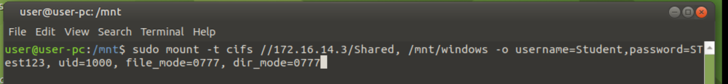
Shown below is capture of the command used to create a mounting point for the file transfer.
A new directory was created in the mount directory and named Windows.

A small script was created and executed using the cron command ./ filepath.

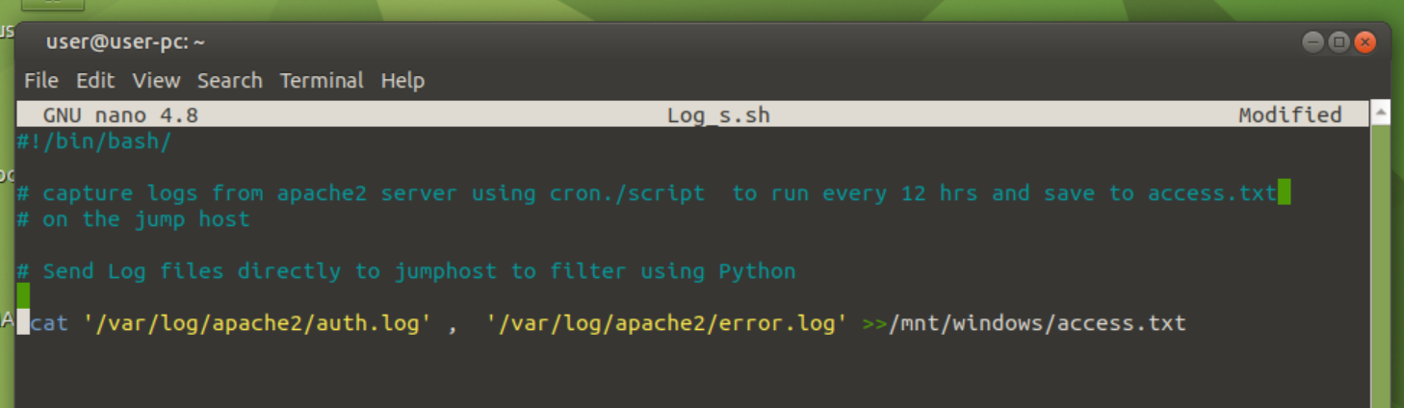

The log files are saved to file through the mount.

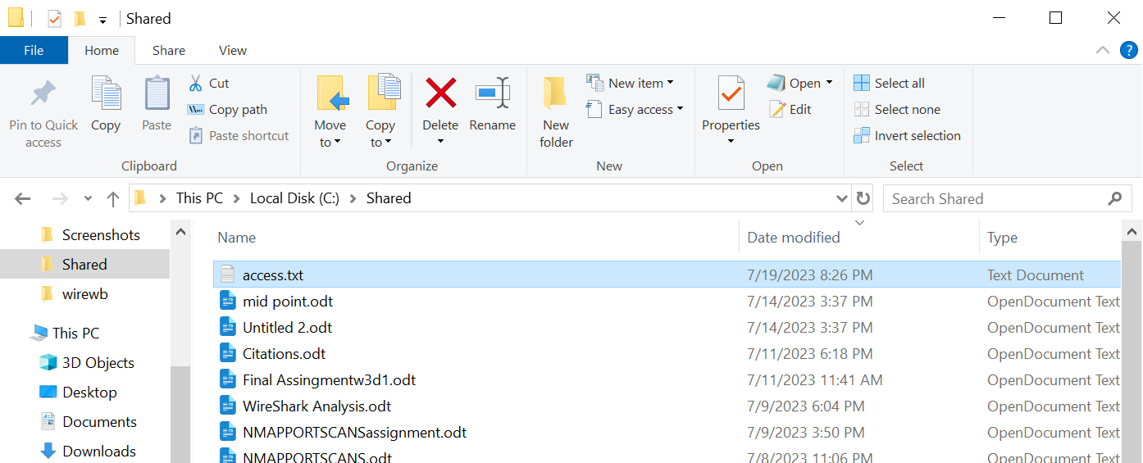

The captured files showing the Logged errors.
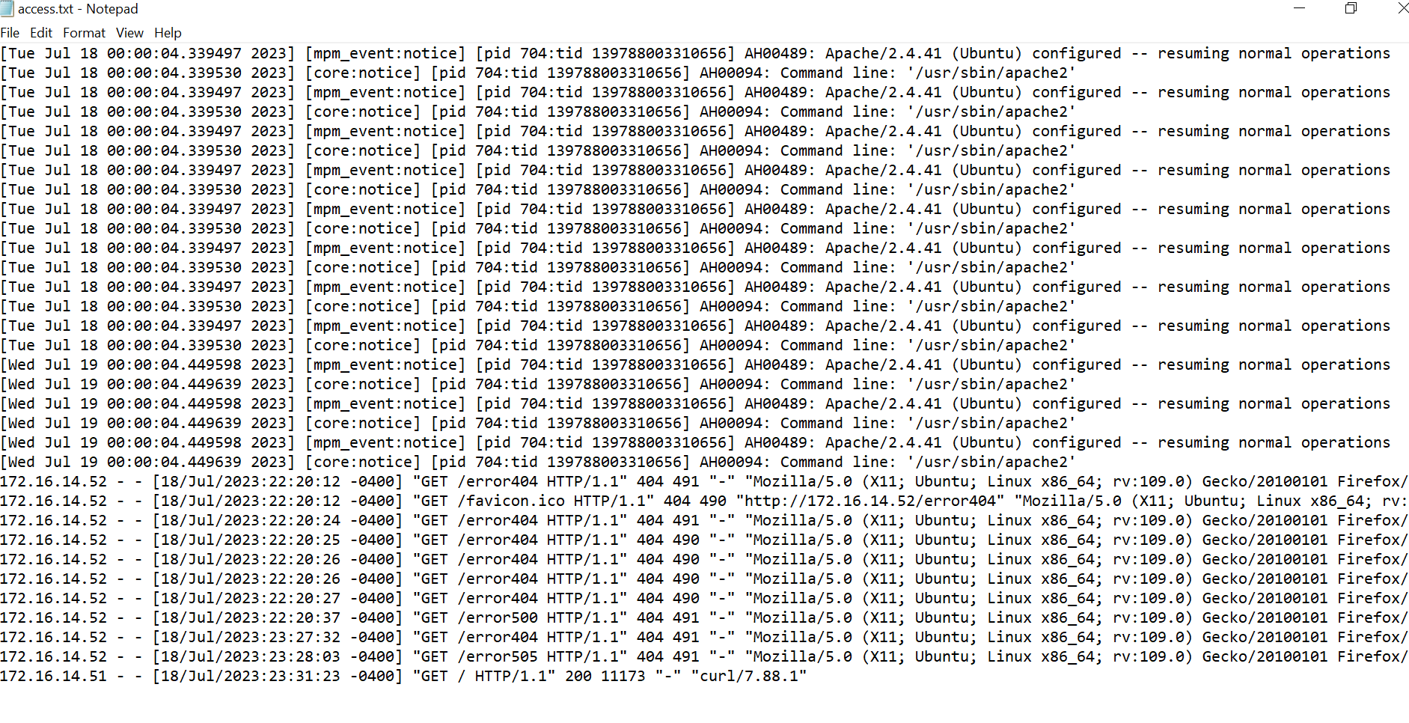

A python script was used to filter and sort the log files.

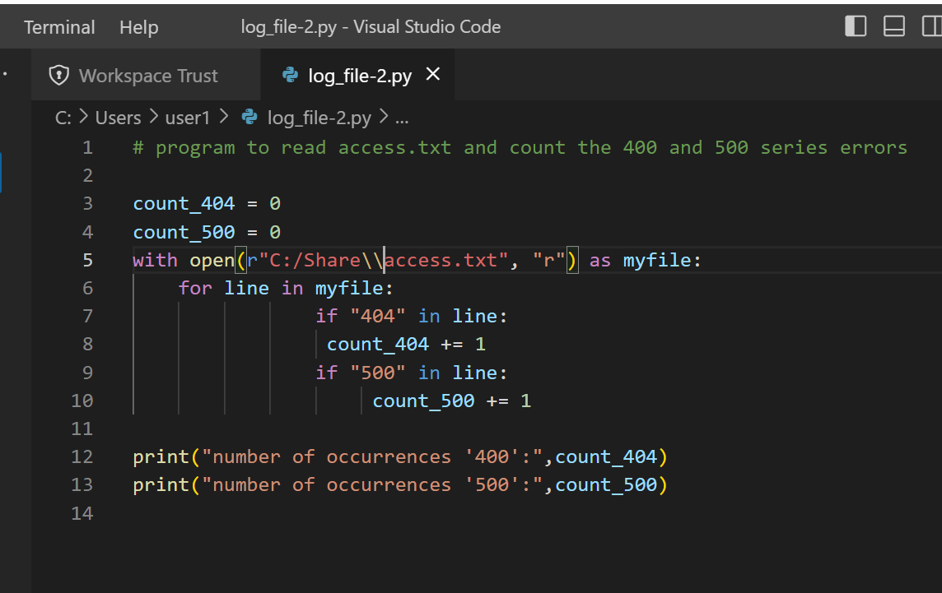

Citations:
Crontab commands in Linux, https://www.geeksforgeeks.org/crontab-in-linux-with-examples/A-143, 9th Floor, Sovereign Corporate Tower, Sector-136, Noida, Uttar Pradesh - 201305

Python https://docs.python.org › library
© Copyright 2001-2023, Python Software Foundation.

UBUNTU https://ubuntu.com/ © 2023 Canonical Ltd. Ubuntu and Canonical are registered trademarks of Canonical Ltd.

A special thanks to the LHL for all the training, help and support to create this project.

